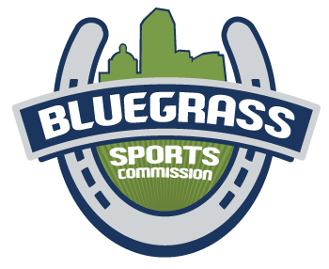

Bluegrass Sports Commission Summer Internship
The Bluegrass Sports Commission is seeking a qualified summer intern for our events team. The ideal intern is able to take ownership of assigned tasks and play a key role in executing events. This internship will provide tangible, hands‐on event management experience.
Who: The ideal candidate is a college student working toward a sports management, marketing, or related degree that has a willingness to learn, ability to problem solve and works well with others.
When: June 1 – August 15 (start and end dates are negotiable).
Where: The internship will primarily take place in-person at the Bluegrass Sports Commission office (333 W. Vine St, Suite 300, Lexington, KY 40507), with event operations taking place at event sites (Lexington/Louisville).
What: Intern will be working on projects related to the Bluegrass Sports Commission and our
signature events, the Bluegrass State Games and A Midsummer Night’s Run.
Job Description: Will assist in organizing and conducting the Bluegrass State Games and A Midsummer Night’s Run. Duties will include but are not limited to:
- Event planning
- Event promotion
- Social media marketing
- Communicating with participants and coaches
- Event set up and tear down
Prior experience is a bonus, but not required.
Hours: 20 hours per week plus additional hours during events. Office hours are Monday-Friday from 9:00 am – 5:00 pm. Scheduled office hours for intern are flexible. Intern must be able to work the weekends of July 12-14, July 19-21, July 26-28, and August 10.

Benefits of Bluegrass Sports Commission Internship
- Earn college credit
- Gain hands-on sporting-event experience
- Build resume for future

Deadline: May 1, 2024

To Apply: Those interested can apply via Handshake or by emailing their resume to Kyle Childers at kyle@bluegrasssports.org.

